

SENTIMENT ANALYSIS FOR PRODUCT REVIEW AND RECOMMENDATION

A PROJECT REPORT
on
ROBOTIC PROCESS AUTOMATION

Submitted by
ATHITYAA A

in partial fulfillment of the requirement for the award of the degree
of
BACHELOR OF TECHNOLOGY
in

ARTIFICIAL INTELLIGENCE
AND DATA SCIENCE

K.S. RANGASAMY COLLEGE OF TECHNOLOGY
(Autonomous)
TIRUCHENGODE – 637 215

MAY 2026

K.S. RANGASAMY COLLEGE OF TECHNOLOGY TIRUCHENGODE - 637 215
BONAFIDE CERTIFICATE

Certified that this project report titled “Sentiment analysis for product review and recommendation” is the bonafide work of ATHITYAA A (2303737724321006) who carried out the project under my supervision. Certified further, that to the best of my knowledge the work reported herein does not form part of any other project report or dissertation on the basis of which a degree or award was conferred on an earlier occasion on this or any other candidate.

SIGNATURE Dr.S.SARUMATHI,M.E..Ph.D.,
HEAD OF THE DEPARTMENT
Professor
Department of Artificial Intelligence and Data Science
K.S.Rangasamy College of Technology Tiruchengode - 637 215

Submitted for the viva-voce examination held on

Internal Examiner 1 Internal Examiner 2

DECLARATION

I declare that the project report on “SENTIMENT ANALYSIS FOR PRODUCT REVIEW AND RECOMMENDATION” is the result of original work done by me and best of my knowledge. This project report is submitted on the partial fulfilment of the requirement of the award of Degree of Artificial Intelligence and Data Science.

Signature

ATHITYAA A

Place: Tiruchengode Date:

ACKNOWLEDGEMENT

We wish to express our sincere gratitude to our honourable Chairman Thiru.
R. SRINIVASAN, BBM., MISTE., for providing immense facilities at our institution.

We would like to express our sincere gratitude to Principal Dr. R.GOPALAKRISHNAN , M.E., Ph.D. for providing the necessary resources and facilities for the completion of this project work report. Your continuous support and encouragement have been invaluable throughout this endeavour.
We proudly render our immense gratitude to the Head of the Department Dr.
S. SARUMATHI, M.E., Ph.D., for her guidance and support in shaping the direction of this project. Your insightful feedback and expertise have been instrumental in refining our approach and methodology.
We wish to extend our sincere thanks to all faculty members of our Artificial Intelligence and Data Science Department for their valuable suggestions, kind co- operation and constant encouragement for successful completion of this project.
We wish to acknowledge the help received from various Departments and various individuals during the preparation and editing stages of the manuscript.

ABSTRACT

This project focuses on automating customer product review analysis using sentiment analysis techniques integrated within UiPath. With the rapid growth of online shopping, customers frequently express their opinions about products through textual reviews, which contain valuable insights for businesses. The system developed in this work reads customer reviews from an input dataset, processes the text, and applies sentiment analysis to classify each review as positive, negative, or neutral. Using UiPath’s automation capabilities, the workflow assigns sentiment scores, generates product-level recommendations, and outputs a structured report for decision-making. This automated solution helps organizations understand customer satisfaction trends, identify areas requiring improvement, and enhance product promotion strategies. The approach demonstrates how combining Robotic Process Automation (RPA) with Natural Language Processing (NLP) can improve efficiency, accuracy, and scalability in customer feedback evaluation.The results of this system can support strategic planning across marketing and product development teams. It also reduces manual effort involved in reading large volumes of customer reviews. Overall, this automated sentiment analysis model contributes to faster, data-driven decision-making in business environments.

TABLE OF CONTENT

CHAPTER TITLE PAGE NO.
ABSTRACT 5
7
- INTRODUCTION
  - ABOUT THE PROJECT 7
  - PROJECT SCOPE 7
  - UIPATH OBJECTIVES 8
  - AIM AND SCOPE 8
- LITERATURE SURVEY 9
- METHODOLOGY AND IMPLEMENTATION 12
  - EXISTING SYSTEM 12
  - PROPOSED SYSTEM 12
  - MODULES 13
  - OVERVIEW OF RPA 13
  - RPA FEATIRES 14
- RESULTS AND DISCUSSIONS 15
  - RESULTS 15
  - DISCUSSION 19
- CONCLUSION FUTURE WORK 22
  - CONCLUSION 22
  - FUTURE WORK 22
- REFERENCES 23

CHAPTER -1 INTRODUCTION

ABOUT THE PROJECT
Customer Product Review and Recommendation using Sentiment Analysis in UiPath is a project designed to automate the process of interpreting customer feedback from online platforms or business records. Customers share numerous reviews in natural language, which can contain emotions, opinions, and experiences related to products. Manually analyzing these reviews is time-consuming and often inaccurate. This project uses UiPath’s automation and text-processing capabilities to classify reviews as positive, negative, or neutral and provide meaningful recommendations for business improvement and decision-making.

PROJECT SCOPE
The scope of this project includes reading customer reviews from an input dataset, performing sentiment analysis, categorizing the emotional tone of each review, and generating automated recommendations based on the sentiment results. It covers the use of UiPath workflows, NLP-based sentiment analysis activities, data preprocessing, error handling, and output generation. The system is intended for use by businesses such as e- commerce companies, retail stores, or service-based platforms that rely heavily on customer feedback to enhance product quality and customer satisfaction.

Ui PATH OBJECTIVE
The main objectives of implementing this project in UiPath are to automate the extraction and processing of customer review data, integrate sentiment analysis activities for efficient and accurate text classification, and minimize manual effort while ensuring consistency in interpreting customer feedback. The project also aims to generate automated Excel-based outputs that include sentiment scores and recommendations, providing businesses with actionable insights. Overall, the objective is to demonstrate the combined power of Robotic Process Automation (RPA) and Natural Language Processing (NLP) in delivering an intelligent, scalable, and reliable decision-support system.

AIM AND SCOPE

The aim of this project is to develop a fully automated, accurate, and scalable sentiment analysis system that can support businesses in understanding customer perceptions. The scope extends to analyzing review patterns, identifying common issues in negative feedback, highlighting strengths in positive reviews, and offering systematic recommendations for product improvement and marketing strategies. By integrating UiPath automation, the project ensures faster processing, reduced human error, and enhanced decision-making capabilities across various business units.

CHAPTER 2 LITERATURE REVIEW

Introduction to Sentiment Analysis

Sentiment analysis is a core technique within Natural Language Processing (NLP) that focuses on interpreting emotions expressed in text. It enables systems to categorize opinions as positive, negative, or neutral by analyzing linguistic patterns. This field has gained significant importance due to the rapid growth of user-generated content on social media and e- commerce platforms. Businesses rely on sentiment insights to evaluate customer satisfaction, track product perception, and refine marketing strategies. Sentiment analysis thus serves as a foundation for automated review interpretation in modern digital environments.

Text Mining and Natural Language Processing (NLP)

Text mining involves extracting structured information from large collections of unstructured text, allowing organizations to derive actionable insights. NLP complements text mining by enabling machines to understand, process, and generate human language with high accuracy. Techniques like tokenization, stemming, lemmatization, and part-of-speech tagging help transform raw textual data into analyzable formats. Together, these methods support advanced text classification, pattern recognition, and opinion extraction. Their integration has revolutionized how businesses interpret customer feedback at scale.

Machine Learning Techniques for Sentiment Classification
Machine learning algorithms play a crucial role in automatically learning patterns from labelled datasets and classifying text into sentiment categories. Models such as Naïve Bayes, Support Vector Machines (SVM), Logistic Regression, and deep learning networks have shown high accuracy in sentiment prediction. These algorithms analyse words, phrases, and contextual information to generate sentiment scores. Modern advancements like LSTM and transformer models further enhance understanding of long- range dependencies in text. Such techniques form the computational backbone of many sentiment-driven applications.

Lexicon-Based Approaches in Sentiment Analysis

Excel plays a significant role in automation workflows due to its simplicity and ability to store structured data. Lexicon-based approaches rely on predefined dictionaries where words are associated with sentiment scores. These methods evaluate the polarity of sentences by matching terms with sentiment lexicons such as Senti WordNet or VADER. They are easy to implement, do not require training data, and provide transparent interpretation. However, their performance may vary depending on domain- specific vocabulary and contextual usage.

Role of Automation in Data Processing

Automation greatly simplifies the handling of large datasets by eliminating repetitive manual tasks. It enables faster data extraction, cleaning, formatting, and processing, which are essential for accurate sentiment analysis workflows. Automated systems minimize human errors

and ensure consistency across multiple data sources. They also allow organizations to process real-time data and generate insights more efficiently. In sentiment analysis, automation ensures a seamless flow from input acquisition to final recommendation generation.

Robotic Process Automation (RPA) in Business Analytics

RPA tools automate rule-based processes such as data entry, report generation, and system navigation. They improve the accuracy and speed of analytical workflows while reducing operational costs. In customer feedback analysis, RPA enables end-to-end automation of collecting, processing, and summarizing data. This integration enhances decision-making and supports data-driven strategies.

UiPath Capabilities for Text and Data Handling
UiPath provides a rich set of features supporting text extraction, data manipulation, string operations, and Excel automation. Its activities allow users to read files, process text, categorize values, and perform transformations with minimal coding effort. UiPath also supports integration with machine learning models, APIs, and Python scripts, making it highly adaptable for NLP tasks. Its drag-and-drop workflow design helps users build complex automations efficiently. These capabilities make UiPath a suitable platform for implementing sentiment analysis solutions.

Sentiment Analysis Integration with RPA Tools
Recent research highlights the increasing trend of combining RPA with sentiment analysis for improved business intelligence. This integration allows organizations to automate text collection, apply NLP techniques, and generate insights without human involvement. RPA platforms can call external models or built-in ML activities to classify customer sentiments accurately. Such workflows support real-time monitoring and automated decision-making processes. As a result, businesses benefit from faster response times and improved customer engagement.

Applications of Sentiment Analysis & Research

In e-commerce, sentiment analysis is widely used to measure customer satisfaction, evaluate product quality, and analyse shopping experiences. Online customer reviews provide valuable insights that can guide product improvements and marketing strategies. Automated sentiment detection helps businesses identify positive trends, recurring complaints, and areas needing attention. It also supports personalized recommendation systems by understanding customer preferences. This makes sentiment analysis an essential tool in enhancing e-commerce service quality. Although many studies explore sentiment analysis techniques, few offer a fully automated framework combining NLP and RPA for end-to-end review processing. Traditional sentiment analysis methods often require manual data preparation and programming knowledge. Many existing tools are not designed for non-technical users or business analysts. There is a growing need for a user-friendly, automation-based solution that minimizes manual effort while ensuring accuracy. This study addresses this gap by proposing a UiPath-driven sentiment analysis system.

CHAPTER 3

METHODOLOGY AND SYSTEM IMPLEMENTATION

  - EXISTING SYTEM
In the existing manual review-evaluation process, customer feedback is typically analyzed by human operators who read each review and classify it as positive, negative, or neutral. This method is time-consuming, highly subjective, and prone to human error due to inconsistent interpretations. Additionally, manual review classification cannot scale efficiently when the number of reviews increases, making it difficult for organizations to respond promptly. Reports also require manual preparation, which increases workload and delays decision-making. Overall, the existing system lacks automation, accuracy, and real-time processing capabilities.

PROPOSED SYTEM
The proposed system introduces an automated, UiPath-based workflow that performs sentiment analysis using rule-based logic and VB.NET expressions. The system reads customer review data from Excel, processes sentiment scores automatically, and generates labels and recommendations without human intervention. This approach eliminates manual errors, increases operational efficiency, and accelerates decision-making. The system produces consistent sentiment classification and generates structured outputs suitable for business reporting. By combining RPA with NLP-inspired logic, the proposed system ensures accuracy, scalability, and quick turnaround time for analyzing large datasets.

MODULES
The automation workflow consists of several interconnected modules that collectively streamline the document-generation process. The Input Module reads the Excel file and loads all customer review data into UiPath. It prepares the DataTable so the system can start processing.
The Processing Module analyzes each review by calculating the sentiment score and deciding whether it is positive, negative, or neutral. It also generates a suitable recommendation for each review automatically.
The Output Module saves all the processed results back into an Excel file. It updates the sentiment score, label, and recommendation and generates the final report.

OVERVIEW OF RPA
Robotic Process Automation (RPA) is a technology that enables software robots to mimic human actions and automate repetitive business tasks. RPA bots work with structured data, interact with applications, perform calculations, and handle workflows just like human users do, but with greater accuracy and speed. RPA is widely used across industries for tasks such as data entry, form processing, report generation, and customer support. It reduces operational costs, minimizes human errors, and improves overall productivity. In the context of sentiment analysis, RPA simplifies data processing and enables continuous, automated analysis without human supervision.

RPA FEATURES
RPA offers numerous powerful features that make it ideal for automating business processes like HR offer letter generation. One of its key features is the ability to perform repetitive tasks with exceptional accuracy, ensuring zero human errors. RPA is also capable of processing large volumes of data at high speed, significantly reducing the overall execution time. Its scalability allows organizations to expand their automation processes as required without additional manual effort. Powerful integration capabilities enable RPA bots to work seamlessly with applications such as Excel, Word, web browsers, email clients, and databases. Additionally, RPA tools provide detailed logs and monitoring capabilities, helping organizations maintain transparency and track process performance. The user-friendly nature of RPA ensures that even non-technical users can understand and manage automation workflows, making it a widely accessible solution for various industries.

CHAPTER 4 RESULTS AND DICUSSION

RESULTS
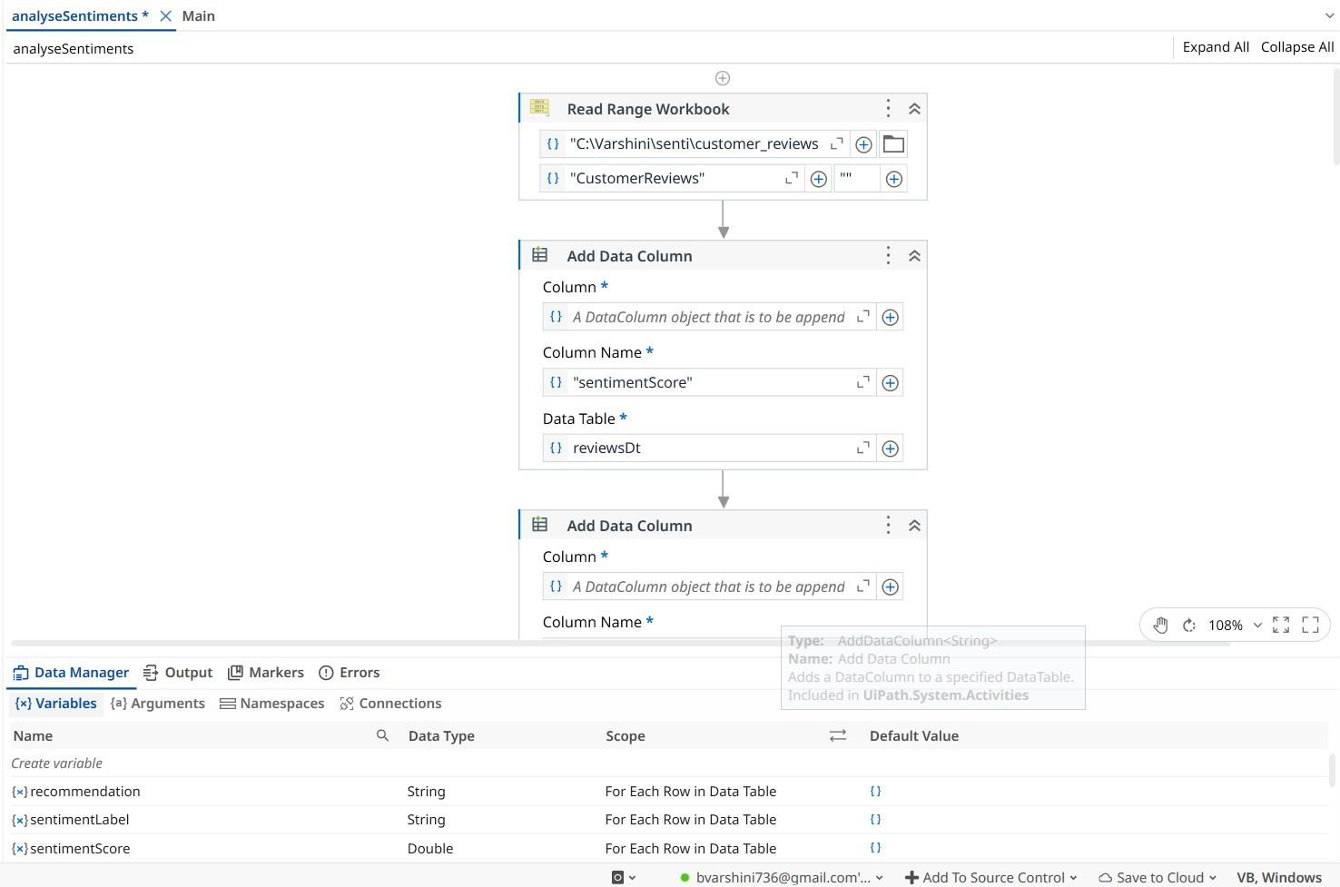

Fig 1 : Main.xaml
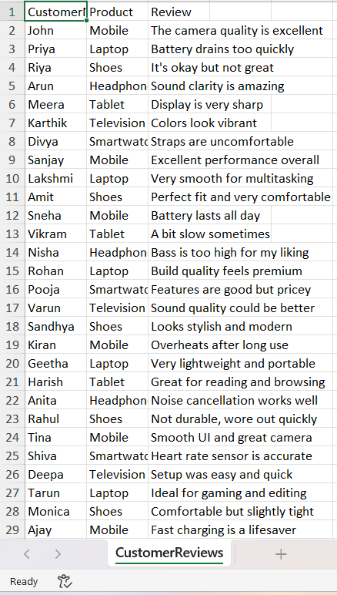

Fig 2 : Data with excel

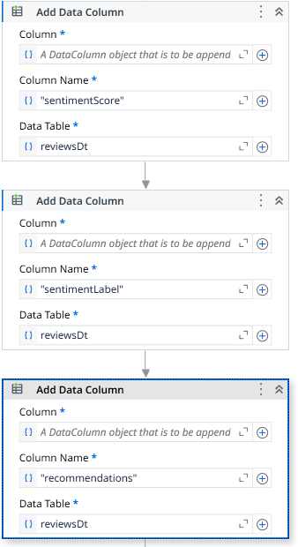
Fig 3 : Added columns in workbook
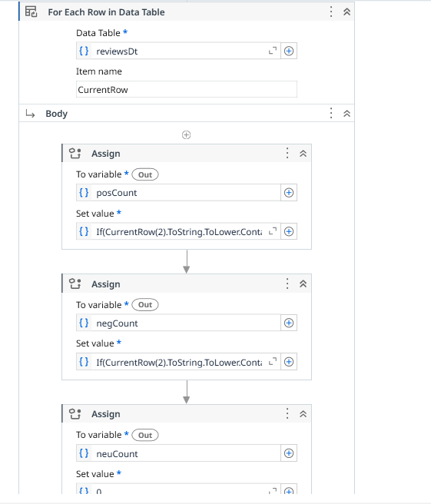
Fig 4: for each row activity

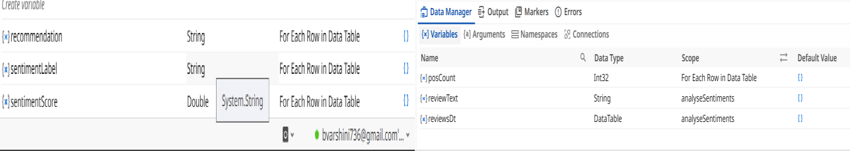
Fig 5: Created variables

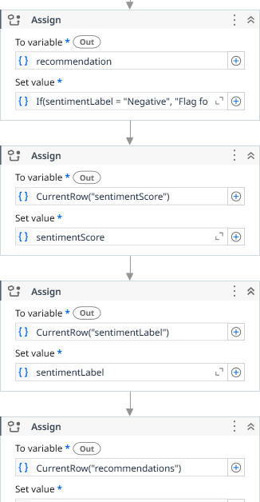

Fig 6 : Assign activities to evaluate the analysis

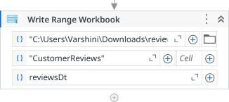
Fig 7: To write in the Workbook

FINAL OUTPUT
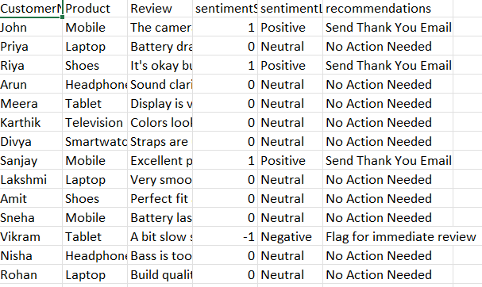
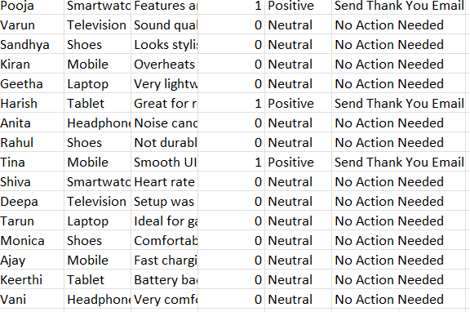

Fig 8: Classified the recommendations

DISCUSSION

Detailed Steps of the Automation Development Process Step 1: Requirement Analysis
The first step involves understanding the problem and defining what the automation needs to achieve. For this project, the primary requirement is to read customer reviews, calculate sentiment scores, classify them, and generate recommendations automatically. At this stage, all inputs (Excel data), outputs (updated Excel report), and rules (sentiment logic, VB.NET expressions, workflow structure) are identified. Any constraints, such as software limitations, data formats, and version compatibility, are also documented.

Step 2: Process Mapping and Workflow Design
A process flow is created to outline reading Excel data, adding columns, looping through reviews, and writing results back. Flowcharts help visualize the steps and reduce logic errors. This design ensures every stage of the automation is planned before development.

Step 3: Environment Setup and Tool Configuration
UiPath Studio is set up and required packages like Excel and System activities are installed. The dataset is prepared with proper columns and folders. Variables and DataTables are created to support workflow execution smoothly.

Step 4: Identifying Automation Feasibility
The input Excel file is read using Read Range into a DataTable. New columns such as sentimentScore and recommendation are added. Initial variables and defaults are prepared to ensure structured processing before

Step 5: Development of Core Logic (Processing Loop)
A For Each Row loop performs the main sentiment logic for each review. VB.NET expressions classify sentiment and generate recommendations. The DataTable is updated in real time, ensuring accurate results for each row without type mismatches. The robot calculates sentiment score, determines the sentiment label, and generates appropriate recommendations. All these results are written back into the DataTable. This stage includes testing each formula to avoid type conversion errors and ensure accurate output.

Step 6: Data Output and Report Generation
The required UiPath activities and packages are installed, including Word Activities, Excel Activities, Mail Automation, and File Management packages. The updated DataTable is exported using Write Range to create a final Excel report. This file contains sentiment scores, labels, and recommendations in a simple, readable format suitable for business decision- making.

Step 7: Error Handling and Validation
To ensure the workflow runs smoothly, error handling mechanisms such as Try-Catch blocks and validation checks are added. This includes handling empty cell errors, incorrect data types, missing files, or workbook access issues. Validation ensures that sentiment scores are calculated correctly and that no records are skipped or processed incorrectly. This makes the automation robust and reliable.

Step 8: Testing and Debugging

Debug mode is used to verify variable values and find logic issues. Test cases with different data types and empty rows ensure the bot behaves correctly. This step confirms that the automation works reliably. Different test cases—such as empty rows, extreme values, or missing columns—are used to ensure the bot handles all scenarios. This step ensures the automation performs consistently under various conditions.

Step 9: Optimization and Performance Improvement
Unnecessary activities are removed, loops are optimized, and variables are simplified to improve execution speed. Efficient data handling techniques, such as avoiding repeated Excel interactions and using in-memory DataTables, are implemented. Ensuring minimal activity usage enhances both performance and readability of the workflow.

Step 10: Documentation and Deployment
A complete documentation is created explaining the workflow design, logic, variables, dependencies, and output format. After documentation, the bot is deployed to the intended environment or shared as an executable process. Users are trained to run the automation and interpret the output report. This marks the completion of the automation development lifecycle.

CHAPTER 5 CONCLUSION AND FUTURE WORK

CONCLUSION
The project successfully demonstrated how UiPath can be used to automate sentiment analysis of customer product reviews. By reading data from Excel, processing sentiment scores using VB.NET logic, and generating recommendations automatically, the system reduces manual effort and improves accuracy. The workflow simplifies the entire process of analyzing feedback and provides quick, consistent results that support better decision- making. Overall, the project shows that combining RPA with basic NLP concepts can create an efficient and reliable solution for handling large volumes of customer reviews. The system is capable of analyzing large volumes of customer feedback, assigning sentiment scores, categorizing sentiments as Positive, Negative, or Neutral, and generating actionable recommendations based on these insights. This enables businesses to respond promptly to customer concerns, appreciate positive feedback, and make informed product or service improvements. Overall, the project highlights the efficiency, scalability, and practical benefits of integrating RPA with sentiment analysis, providing a robust solution for intelligent customer feedback management and data-driven decision-making. Additionally, the automation ensures faster processing times and minimizes human errors, increasing operational efficiency. The modular workflow design makes it easy to adapt and expand for other datasets or business domains. Finally, this project serves as a foundation for exploring more advanced AI-driven analytics and predictive customer behavior modelling in the future.

FUTURE WORK
The current implementation of the Customer Product Review and Recommendation system using UiPath successfully automates sentiment analysis and recommendation generation. However, there is significant scope for enhancing the system further to make it more intelligent, scalable, and adaptable to diverse business requirements.
One potential area of future work is the integration of advanced Natural Language Processing (NLP) and Machine Learning algorithms. Currently, the sentiment analysis relies on simple positive, negative, and neutral counts; this can be extended to more sophisticated techniques such as deep learning-based sentiment classification, contextual understanding of reviews, and detection of sarcasm or mixed sentiments. Using models like BERT, RoBERTa, or other transformer-based architectures can greatly improve the accuracy of sentiment predictions, especially for complex sentences or ambiguous customer feedback.
Another important extension could be the support for multiple languages. As businesses expand globally, customer reviews may be submitted in different languages. Implementing multilingual sentiment analysis using pre-trained language models or translation-based pipelines would increase the utility and reach of the system.
The system could also incorporate predictive analytics and trend detection. By analyzing sentiment over time, businesses could identify emerging product issues, seasonal trends, or shifts in customer preferences. This would allow proactive decision-making rather than reactive responses, further enhancing customer satisfaction and operational efficiency.

Integration with other data sources such as social media platforms, customer support tickets, and product ratings could provide a more holistic understanding of customer sentiment. By combining multiple channels of feedback, the system could generate comprehensive recommendations that reflect the overall customer experience.
From a workflow perspective, future enhancements could focus on dynamic and adaptive automation. For instance, the robot could automatically update the Excel or database schema when new review categories or metrics are introduced, reducing maintenance efforts. Additionally, advanced dashboards and visualizations could be added to present real-time sentiment insights to business stakeholders.
Finally, there is an opportunity to explore AI-driven recommendations beyond simple predefined actions. By analyzing patterns in past feedback and actions, the system could suggest personalized solutions, marketing strategies, or product improvements, moving towards a fully intelligent customer feedback management system.
In conclusion, while the current project provides a solid foundation for automated sentiment analysis using UiPath, incorporating advanced NLP, multilingual support, predictive analytics, multi-source integration, and intelligent recommendations will transform it into a comprehensive, future- ready solution capable of addressing complex business challenges

REFERENCE

- https://www.uipath.com/rpa/robotic-process-automation – Learn how RPA can transform repetitive tasks into smooth, automated workflows.

- https://nlp.stanford.edu/ – A foundational resource for understanding how machines interpret human language.

- https://towardsdatascience.com/sentiment-analysis-using-nlp-4ec48d9dcbf7 – A clear guide on applying sentiment analysis techniques to real-world text.

- https://www.researchgate.net/publication/260417430_Sentiment_Analysis_Algo rithms_and_Applications_A_Survey – A detailed survey of popular sentiment analysis methods and their applications.

- https://cs224n.stanford.edu/reports/2009/pdfs/GoA.pdf – A research paper showing how social media data can be analysed for sentiment.

- https://journals.sagepub.com/doi/10.1057/jittc.2016.7 – Insights into how RPA is revolutionizing business processes.

- https://ieeexplore.ieee.org/document/6779248 – A technical resource exploring ML techniques for sentiment detection.

- https://academy.uipath.com – A wonderful place to learn UiPath step by step for free, from beginner to advanced.

